



**BEERME!**

**Julianna Bicz**

X0014xxxx

**James Cadden**

X00143093

**Tomasz Kutela**

X0014xxxx

Table of Contents

Project documentation........................................................................................................................................2

Github & Azure Links...........................................................................................................................................2

Project Proposal..................................................................................................................................................2

Database Schema...............................................................................................................................................3

Screen Shots........................................................................................................................................................4

Project Code........................................................................................................................................................5

Models..........................................................................................................................................................11-12

Controllers.....................................................................................................................................................13-21

Views.............................................................................................................................................................22-25

Links to used images..........................................................................................................................................25

# 

# Project Documentation

## GitHub & Azure links

MVC Project on GitHub: <https://github.com/jamesfcadden/APP_BEER_ME/tree/master/APP_BEER_ME>

Azure Link: <https://appbeerme.azurewebsites.net>

## Project Proposal

Our proposal is to create an app for people who enjoy a refreshing beverage but also demand the most bang for their buck.

Users will be able to query a database of beers and shops to investigate exactly how much alcohol they can purchase on a specified budget. The app will store data on craft beers and where they are available. The user will input an amount of money, e.g. €20, the app will interrogate the database and return exactly which combination of bottles or cans of beer that will provide the highest level of units of alcohol that the user can purchase, and return the amount of change due.

For the developers, the app will analyse beer consumption habits. The client app will point out, for example, most popular beer brands, types, and other habits. The app will have three tables: beers, shops and stock.

## Database Schema

3 Tables.

Beer –Primary Key BeerID and Foreign Key StockID (From Stock table). Linked with Stock table one to many relationship

Stock – Primary Key StockID and two Foreign Keys – ShopID and BeerId. Linked with Beer and Shop tables many to one relationship

Shop - Primary Key Shop and Foreign Key StockID (From Stock table). Linked with Stock table one to many relationship

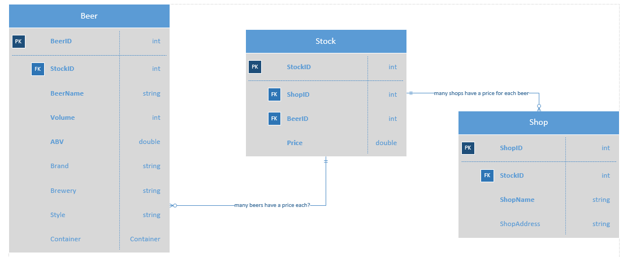

## Screen Shots

Home Screen

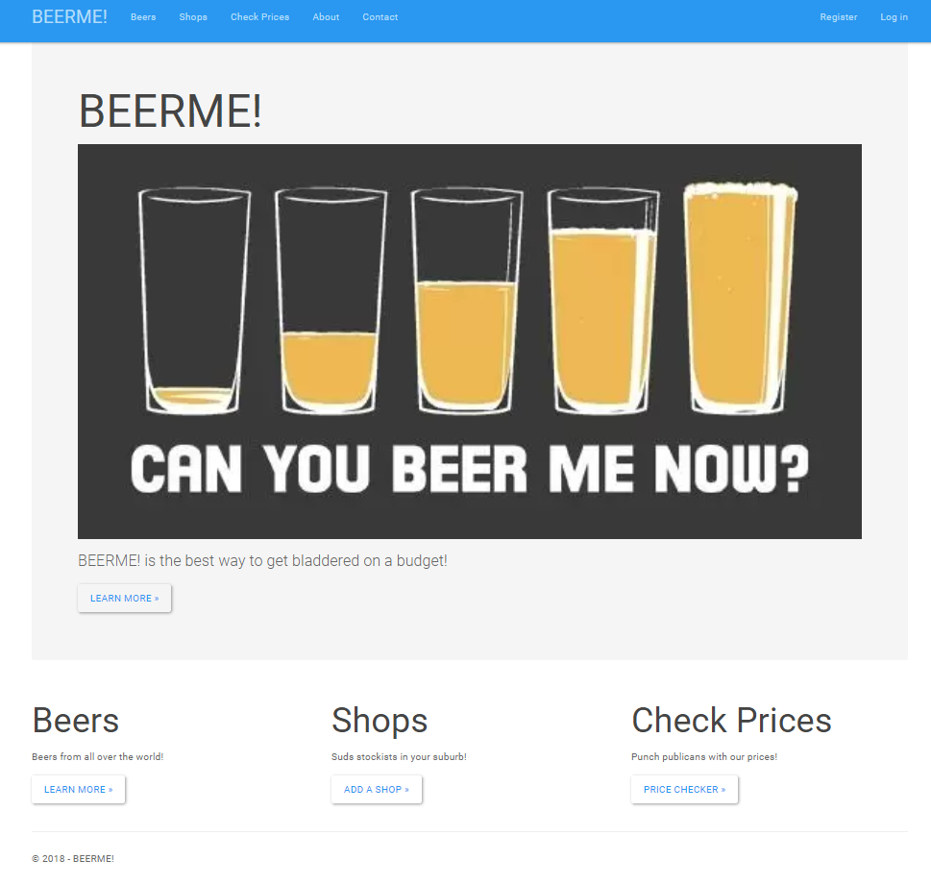

Beers page

On this page, users can view the list of beers already on the database. They can also edit, view details for and delete a beer from the database. Beers are sorted by Name. A search bar is available for the user to search beer name, brewery or style. The user can also create a new beer.

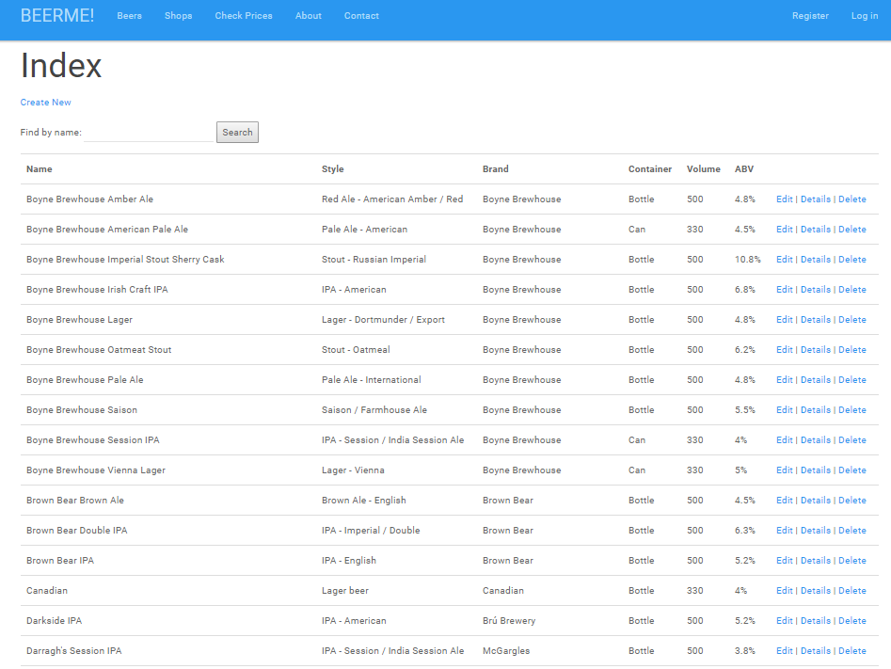

New Beer Details

Each field is mandatory.

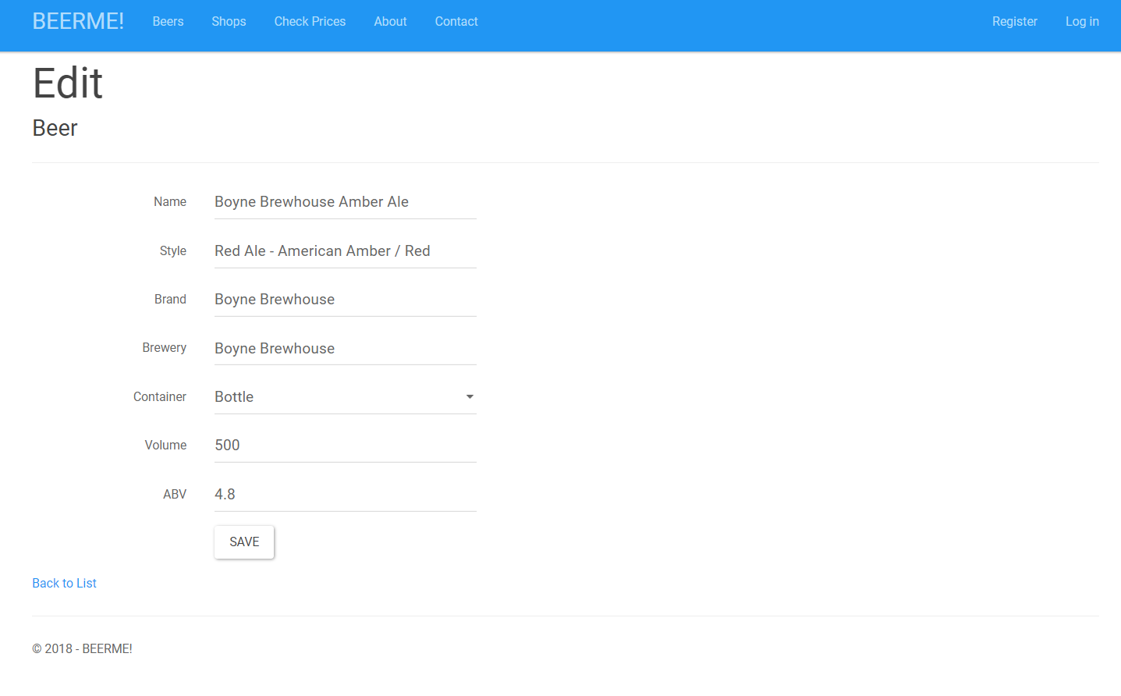

Check Prices Page

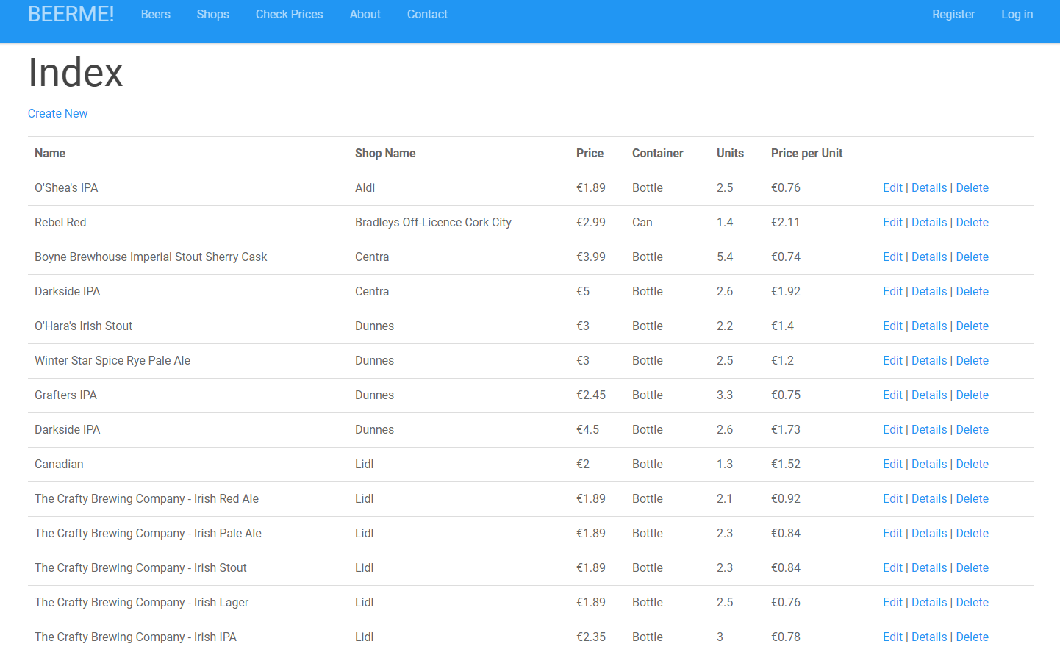

New Shop

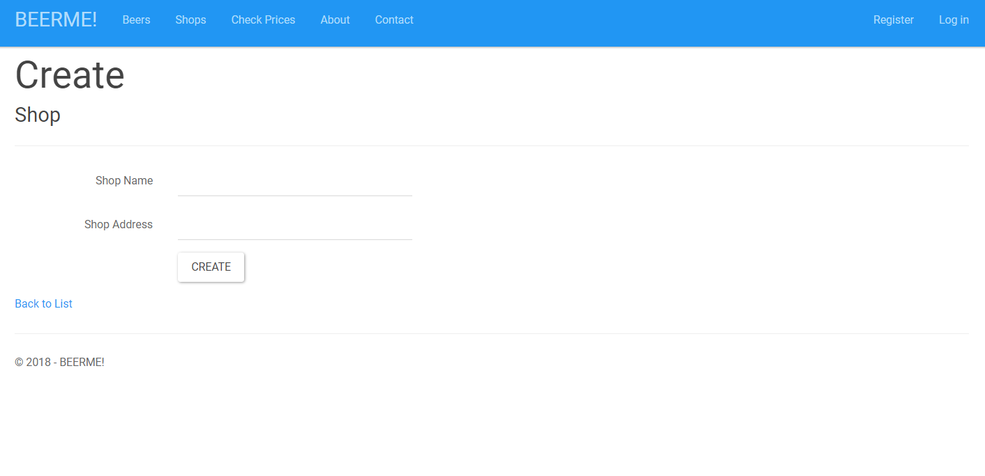

Add new on Check Price page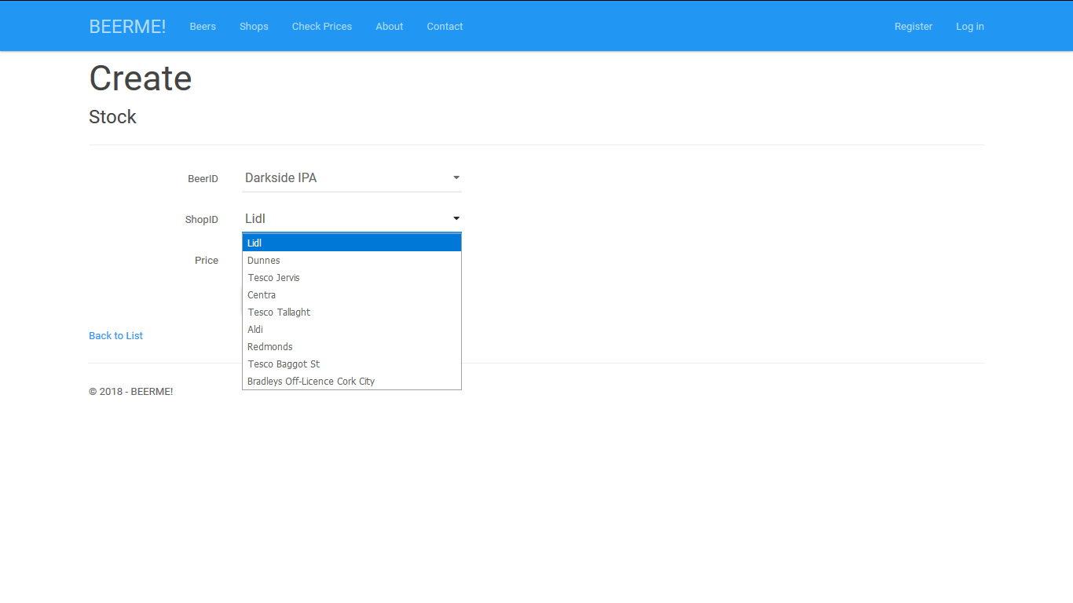

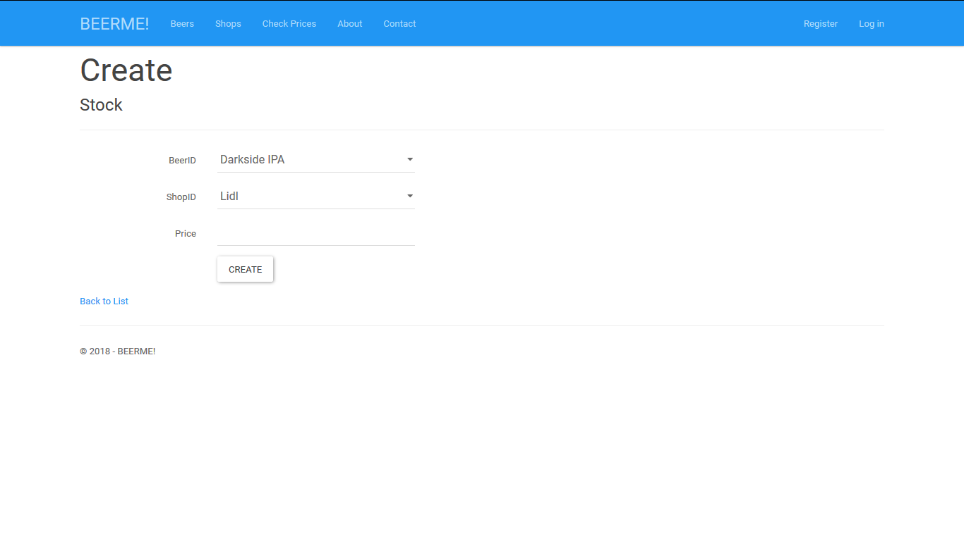

About Us page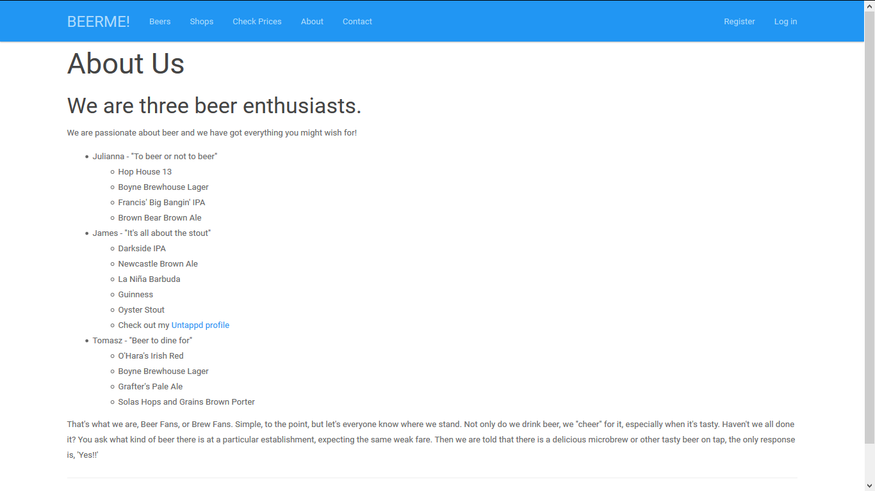

Contact page

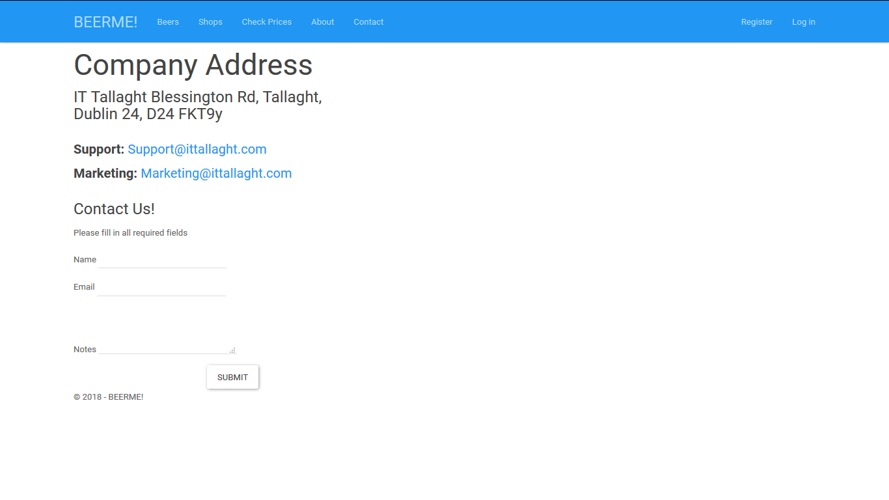

# 

# Project Code

## Models

Beer Model

using System;

using System.Collections.Generic;

using System.ComponentModel.DataAnnotations;

using System.ComponentModel.DataAnnotations.Schema;

using System.Linq;

using System.Web;

using System.Web.Mvc;

namespace APP_BEER_ME.Models

{

public enum Container { Bottle, Can }

public class Beer

{

[Key]

public int BeerID { get; set; }

[Required(ErrorMessage = "The Name field is required ! ")]

public string Name { get; set; }

[Required(ErrorMessage = "The Style field is required ! ")]

public string Style { get; set; }

[Required(ErrorMessage = "The Brand field is required ! ")]

public string Brand { get; set; }

[Required(ErrorMessage = "The Brewery field is required ! ")]

public string Brewery { get; set; }

[Required(ErrorMessage = "The Container field is required ! ")]

public Container Container { get; set; }

public int Volume { get; set; }

[Required(ErrorMessage = "The ABV field is required ! ")]

public double ABV { get; set; }

public virtual ICollection<Stock> Stocks { get; set; }

}

}

Shop Model

using System;

using System.Collections.Generic;

using System.ComponentModel.DataAnnotations;

using System.ComponentModel.DataAnnotations.Schema;

using System.Linq;

using System.Web;

namespace APP_BEER_ME.Models

{

public class Shop

{

[Key]

public int ShopID { get; set; }

[Required]

[Display(Name = "Shop Name")]

public string ShopName { get; set; }

[Required]

[Display(Name = "Shop Address")]

public string ShopAddress { get; set; }

public virtual ICollection<Stock> Stocks { get; set; }

}

}

Stock Model

using System;

using System.Collections.Generic;

using System.ComponentModel.DataAnnotations;

using System.ComponentModel.DataAnnotations.Schema;

using System.Linq;

using System.Web;

using System.Web.Mvc;

namespace APP_BEER_ME.Models

{

public class Stock

{

[Required]

public int StockID { get; set; }

public int BeerID { get; set; }

public int ShopID { get; set; }

[Required]

public double Price { get; set; }

public virtual Beer Beer { get; set; }

public virtual Shop Shop { get; set; }

}

}

## Controllers

Beer Controller

using System;

using System.Collections.Generic;

using System.Data;

using System.Data.Entity;

using System.Linq;

using System.Net;

using System.Web;

using System.Web.Mvc;

using APP_BEER_ME.DAL;

using APP_BEER_ME.Models;

using System.Data.Entity.Infrastructure;

namespace APP_BEER_ME.Controllers

{

public class BeerController : Controller

{

private APP_BEER_MEContext db = new APP_BEER_MEContext();

// GET: Beer

public ViewResult Index(string sortOrder, string searchString)

{

ViewBag.NameSortParm = String.IsNullOrEmpty(sortOrder) ? "name_desc" : "";

var beers = from b in db.Beers

select b;

switch (sortOrder)

{

default:

beers = beers.OrderBy(s => s.Name);

break;

}

if (!String.IsNullOrEmpty(searchString))

{

beers = beers.Where(b => b.Name.Contains(searchString) || b.Style.Contains(searchString) || b.Brewery.Contains(searchString));

}

return View(beers.ToList());

}

// GET: Beer/Details/5

public ActionResult Details(int? id)

{

if (id == null)

{

return new HttpStatusCodeResult(HttpStatusCode.BadRequest);

}

Beer beer = db.Beers.Find(id);

if (beer == null)

{

return HttpNotFound();

}

return View(beer);

}

// GET: Beer/Create

public ActionResult Create()

{

return View();

}

[HttpPost]

[ValidateAntiForgeryToken]

public ActionResult Create([Bind(Include = "Name, Style, Brand, Brewery, Container, Volume, ABV")]Beer beer)

{

try

{

if (ModelState.IsValid)

{

db.Beers.Add(beer);

db.SaveChanges();

return RedirectToAction("Index");

}

}

catch (DataException /* dex */)

{

ModelState.AddModelError("", "Unable to save changes. Try again, and if the problem persists see your system administrator.");

}

return View(beer);

}

// GET: Beer/Edit/5

public ActionResult Edit(int? id)

{

if (id == null)

{

return new HttpStatusCodeResult(HttpStatusCode.BadRequest);

}

Beer beer = db.Beers.Find(id);

if (beer == null)

{

return HttpNotFound();

}

return View(beer);

}

// POST: Beer/Edit/5

[HttpPost]

[ValidateAntiForgeryToken]

public ActionResult Edit([Bind(Include = "BeerID,Name,Style,Brand,Brewery,Container,Volume,ABV")] Beer beer)

{

if (ModelState.IsValid)

{

db.Entry(beer).State = EntityState.Modified;

db.SaveChanges();

return RedirectToAction("Index");

}

return View(beer);

}

// GET: Beer/Delete/5

public ActionResult Delete(int? id, bool? saveChangesError = false)

{

if (id == null)

{

return new HttpStatusCodeResult(HttpStatusCode.BadRequest);

}

if (saveChangesError.GetValueOrDefault())

{

ViewBag.ErrorMessage = "Delete failed. Try again, and if the problem persists see your system administrator.";

}

Beer beer = db.Beers.Find(id);

if (beer == null)

{

return HttpNotFound();

}

return View(beer);

}

// POST: Beer/Delete/5

[HttpPost]

[ValidateAntiForgeryToken]

public ActionResult Delete(int id)

{

try

{

Beer beer = db.Beers.Find(id);

db.Beers.Remove(beer);

db.SaveChanges();

}

catch (DataException/* dex */)

{

//Log the error (uncomment dex variable name and add a line here to write a log.

return RedirectToAction("Delete", new { id = id, saveChangesError = true });

}

return RedirectToAction("Index");

}

protected override void Dispose(bool disposing)

{

if (disposing)

{

db.Dispose();

}

base.Dispose(disposing);

}

}

}

Shop Controller

using System;

using System.Collections.Generic;

using System.Data;

using System.Data.Entity;

using System.Linq;

using System.Net;

using System.Web;

using System.Web.Mvc;

using APP_BEER_ME.DAL;

using APP_BEER_ME.Models;

using System.Data.Entity.Infrastructure;

namespace APP_BEER_ME.Controllers

{

public class ShopController : Controller

{

private APP_BEER_MEContext db = new APP_BEER_MEContext();

// GET: Shop

public ActionResult Index(string sortOrder)

{

ViewBag.NameSortParm = String.IsNullOrEmpty(sortOrder) ? "shopname_desc" : "";

var shops = from s in db.Shops

select s;

switch (sortOrder)

{

default:

shops = shops.OrderBy(s => s.ShopName);

break;

}

return View(shops.ToList());

}

// GET: Shop/Details/5

public ActionResult Details(int? id)

{

if (id == null)

{

return new HttpStatusCodeResult(HttpStatusCode.BadRequest);

}

Shop shop = db.Shops.Find(id);

if (shop == null)

{

return HttpNotFound();

}

return View(shop);

}

// GET: Shop/Create

public ActionResult Create()

{

return View();

}

[HttpPost]

[ValidateAntiForgeryToken]

public ActionResult Create([Bind(Include = "ShopName, ShopAddress")]Shop shop)

{

try

{

if (ModelState.IsValid)

{

db.Shops.Add(shop);

db.SaveChanges();

return RedirectToAction("Index");

}

}

catch (DataException /* dex */)

{

//Log the error (uncomment dex variable name and add a line here to write a log.

ModelState.AddModelError("", "Unable to save changes. Try again, and if the problem persists see your system administrator.");

}

return View(shop);

}

// GET: Shop/Edit/5

public ActionResult Edit(int? id)

{

if (id == null)

{

return new HttpStatusCodeResult(HttpStatusCode.BadRequest);

}

Shop shop = db.Shops.Find(id);

if (shop == null)

{

return HttpNotFound();

}

return View(shop);

}

// POST: Shop/Edit/5

[HttpPost]

[ValidateAntiForgeryToken]

public ActionResult Edit([Bind(Include = "ShopID,ShopName,ShopAddress")] Shop shop)

{

if (ModelState.IsValid)

{

db.Entry(shop).State = EntityState.Modified;

db.SaveChanges();

return RedirectToAction("Index");

}

return View(shop);

}

// GET: Shop/Delete/5

public ActionResult Delete(int? id, bool? saveChangesError = false)

{

if (id == null)

{

return new HttpStatusCodeResult(HttpStatusCode.BadRequest);

}

if (saveChangesError.GetValueOrDefault())

{

ViewBag.ErrorMessage = "Delete failed. Try again, and if the problem persists see your system administrator.";

}

Shop shop = db.Shops.Find(id);

if (shop == null)

{

return HttpNotFound();

}

return View(shop);

}

// POST: Shop/Delete/5

[HttpPost]

[ValidateAntiForgeryToken]

public ActionResult Delete(int id)

{

try

{

Shop shop = db.Shops.Find(id);

db.Shops.Remove(shop);

db.SaveChanges();

}

catch (DataException/* dex */)

{

return RedirectToAction("Delete", new { id = id, saveChangesError = true });

}

return RedirectToAction("Index");

}

protected override void Dispose(bool disposing)

{

if (disposing)

{

db.Dispose();

}

base.Dispose(disposing);

}

}

}

Stock Controller

using System;

using System.Collections.Generic;

using System.Data;

using System.Data.Entity;

using System.Linq;

using System.Net;

using System.Web;

using System.Web.Mvc;

using APP_BEER_ME.DAL;

using APP_BEER_ME.Models;

namespace APP_BEER_ME.Controllers

{

public class StockController : Controller

{

private APP_BEER_MEContext db = new APP_BEER_MEContext();

public double CalcUnits(double ABV, int Volume)

{

double Units = 0;

Units = Volume * (ABV / 100);

return Units;

}

public double CalcPricePerUnit(double ABV, int Volume, double Price)

{

double PricePerUnit = 0;

PricePerUnit = Price / (Volume * (ABV / 100));

return PricePerUnit;

}

// GET: Stock

public ActionResult Index(string sortOrder)

{

ViewBag.NameSortParm = String.IsNullOrEmpty(sortOrder) ? "shopname_desc" : "";

var stocks = db.Stocks.Include(s => s.Beer).Include(s => s.Shop);

switch (sortOrder)

{

default:

stocks = stocks.OrderBy(s => s.Shop.ShopName);

break;

}

return View(stocks.ToList());

}

// GET: Stock/Details/5

public ActionResult Details(int? id)

{

if (id == null)

{

return new HttpStatusCodeResult(HttpStatusCode.BadRequest);

}

Stock stock = db.Stocks.Find(id);

if (stock == null)

{

return HttpNotFound();

}

return View(stock);

}

// GET: Stock/Create

public ActionResult Create()

{

ViewBag.BeerID = new SelectList(db.Beers, "BeerID", "Name");

ViewBag.ShopID = new SelectList(db.Shops, "ShopID", "ShopName");

return View();

}

// POST: Stock/Create

[HttpPost]

[ValidateAntiForgeryToken]

public ActionResult Create([Bind(Include = "StockID,BeerID,ShopID,Price")] Stock stock)

{

try

{

if (ModelState.IsValid)

{

db.Stocks.Add(stock);

db.SaveChanges();

return RedirectToAction("Index");

}

}

catch (DataException /* dex */)

{

ModelState.AddModelError("", "Unable to save changes. Try again, and if the problem persists see your system administrator.");

}

ViewBag.BeerID = new SelectList(db.Beers, "BeerID", "Name", stock.BeerID);

ViewBag.ShopID = new SelectList(db.Shops, "ShopID", "ShopName", stock.ShopID);

return View(stock);

}

// GET: Stock/Edit/5

public ActionResult Edit(int? id)

{

if (id == null)

{

return new HttpStatusCodeResult(HttpStatusCode.BadRequest);

}

Stock stock = db.Stocks.Find(id);

if (stock == null)

{

return HttpNotFound();

}

ViewBag.BeerID = new SelectList(db.Beers, "BeerID", "Name", stock.BeerID);

ViewBag.ShopID = new SelectList(db.Shops, "ShopID", "ShopName", stock.ShopID);

return View(stock);

}

// POST: Stock/Edit/5

[HttpPost]

[ValidateAntiForgeryToken]

public ActionResult Edit([Bind(Include = "StockID,BeerID,ShopID,Price")] Stock stock)

{

if (ModelState.IsValid)

{

db.Entry(stock).State = EntityState.Modified;

db.SaveChanges();

return RedirectToAction("Index");

}

ViewBag.BeerID = new SelectList(db.Beers, "BeerID", "Name", stock.BeerID);

ViewBag.ShopID = new SelectList(db.Shops, "ShopID", "ShopName", stock.ShopID);

return View(stock);

}

// GET: Stock/Delete/5

public ActionResult Delete(int? id, bool? saveChangesError = false)

{

if (id == null)

{

return new HttpStatusCodeResult(HttpStatusCode.BadRequest);

}

if (saveChangesError.GetValueOrDefault())

{

ViewBag.ErrorMessage = "Delete failed. Try again, and if the problem persists see your system administrator.";

}

Stock stock = db.Stocks.Find(id);

if (stock == null)

{

return HttpNotFound();

}

return View(stock);

}

// POST: Stock/Delete/5

[HttpPost]

[ValidateAntiForgeryToken]

public ActionResult Delete(int id)

{

try

{

Stock stock = db.Stocks.Find(id);

db.Stocks.Remove(stock);

db.SaveChanges();

}

catch (DataException/* dex */)

{

//Log the error (uncomment dex variable name and add a line here to write a log.

return RedirectToAction("Delete", new { id = id, saveChangesError = true });

}

return RedirectToAction("Index");

}

protected override void Dispose(bool disposing)

{

if (disposing)

{

db.Dispose();

}

base.Dispose(disposing);

}

}

}

## Views

View Index Beer

@model IEnumerable<APP_BEER_ME.Models.Beer>

@{

ViewBag.Title = "Index";

}

<h2>Index</h2>

<p>

@Html.ActionLink("Create New", "Create")

</p>

@using (Html.BeginForm())

{

<p>

Find by name: @Html.TextBox("SearchString")

<input type="submit" value="Search" />

</p>

}

<table class="table">

<tr>

<th>

@Html.DisplayNameFor(model => model.Name)

</th>

<th>

@Html.DisplayNameFor(model => model.Style)

</th>

<th>

@Html.DisplayNameFor(model => model.Brand)

</th>

<th>

@Html.DisplayNameFor(model => model.Container)

</th>

<th>

@Html.DisplayNameFor(model => model.Volume)

</th>

<th>

@Html.DisplayNameFor(model => model.ABV)

</th>

<th></th>

</tr>

@foreach (var item in Model)

{

<tr>

<td>

@Html.DisplayFor(modelItem => item.Name)

</td>

<td>

@Html.DisplayFor(modelItem => item.Style)

</td>

<td>

@Html.DisplayFor(modelItem => item.Brand)

</td>

<td>

@Html.DisplayFor(modelItem => item.Container)

</td>

<td>

@Html.DisplayFor(modelItem => item.Volume)

</td>

<td>

@Html.DisplayFor(modelItem => item.ABV)%

</td>

<td>

@Html.ActionLink("Edit", "Edit", new { id = item.BeerID }) |

@Html.ActionLink("Details", "Details", new { id = item.BeerID }) |

@Html.ActionLink("Delete", "Delete", new { id = item.BeerID })

</td>

</tr>

}

</table>

View Create Shop

@model APP_BEER_ME.Models.Shop

@{

ViewBag.Title = "Create";

}

<h2>Create</h2>

@using (Html.BeginForm())

{

@Html.AntiForgeryToken()

<div class="form-horizontal">

<h4>Shop</h4>

<hr />

@Html.ValidationSummary(true, "", new { @class = "text-danger" })

<div class="form-group">

@Html.LabelFor(model => model.ShopName, htmlAttributes: new { @class = "control-label col-md-2" })

<div class="col-md-10">

@Html.EditorFor(model => model.ShopName, new { htmlAttributes = new { @class = "form-control" } })

@Html.ValidationMessageFor(model => model.ShopName, "", new { @class = "text-danger" })

</div>

</div>

<div class="form-group">

@Html.LabelFor(model => model.ShopAddress, htmlAttributes: new { @class = "control-label col-md-2" })

<div class="col-md-10">

@Html.EditorFor(model => model.ShopAddress, new { htmlAttributes = new { @class = "form-control" } })

@Html.ValidationMessageFor(model => model.ShopAddress, "", new { @class = "text-danger" })

</div>

</div>

<div class="form-group">

<div class="col-md-offset-2 col-md-10">

<input type="submit" value="Create" class="btn btn-default" />

</div>

</div>

</div>

}

<div>

@Html.ActionLink("Back to List", "Index")

</div>

@section Scripts {

@Scripts.Render("~/bundles/jqueryval")

}

View Stock Index

@model IEnumerable<APP_BEER_ME.Models.Stock>

@{

ViewBag.Title = "Check Prices";

}

<h2>Index</h2>

<p>

@Html.ActionLink("Create New", "Create")

</p>

<table class="table">

<tr>

<th>

@Html.DisplayNameFor(model => model.Beer.Name)

</th>

<th>

@Html.DisplayNameFor(model => model.Shop.ShopName)

</th>

<th>

@Html.DisplayNameFor(model => model.Price)

</th>

<th>

@Html.DisplayNameFor(model => model.Beer.Container)

</th>

<th>

Units

</th>

<th>

Price per Unit

</th>

<th></th>

</tr>

@foreach (var item in Model) {

<tr>

<td>

@Html.DisplayFor(modelItem => item.Beer.Name)

</td>

<td>

@Html.DisplayFor(modelItem => item.Shop.ShopName)

</td>

<td>

€@Html.DisplayFor(modelItem => item.Price)

</td>

<td>

@Html.DisplayFor(modelItem => item.Beer.Container)

</td>

<td>

@Math.Round(((item.Beer.Volume * (item.Beer.ABV / 1000))), 1, MidpointRounding.AwayFromZero)

</td>

<td>

€@Math.Round(item.Price / ((item.Beer.Volume * (item.Beer.ABV / 1000))), 2, MidpointRounding.AwayFromZero)

</td>

<td>

@Html.ActionLink("Edit", "Edit", new { id = item.StockID }) |

@Html.ActionLink("Details", "Details", new { id = item.StockID }) |

@Html.ActionLink("Delete", "Delete", new { id = item.StockID })

</td>

</tr>

}

</table>

<img src="~/images/BeerME.png" width="75%" />

## Links of used images

<https://www.bottleyourbrand.com/beer-label-funny-beer-me-4400>

<https://www.memecenter.com/fun/12997/Can-You-Beer-Me-Now>